SYSTEM LEVEL DESIGN

Concept Generation

Black Box Approach: Device

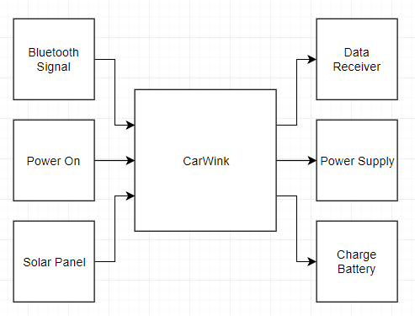

Black Box Approach: Assigned Phone

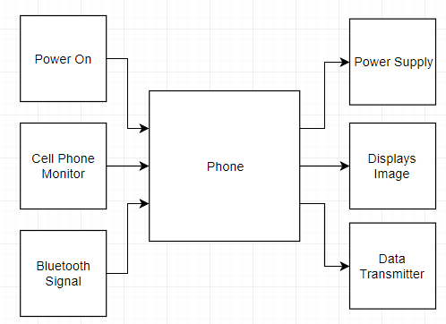

Figure. Black Box Approach of CarWink

Function Diagram

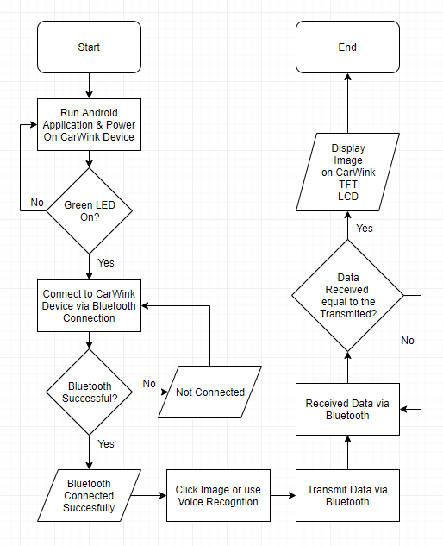

Figure. Function Diagram of CarWink

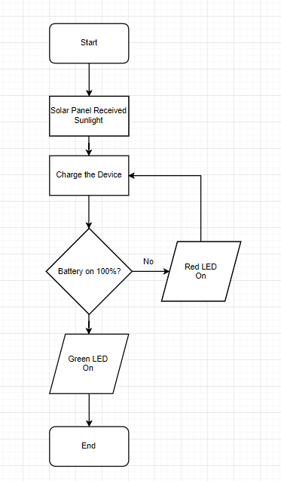

Figure. Function Diagram of Charging the Device

MATERIALS:

|  |  |  |
| --- | --- | --- |
| Material | Quantity | Cost (Php.) |
| 3.5 Inches TFT LCD Screen Module 3.3V/5V | 1 | 998 |
| 3.5 Inches LCD Screen Module for Arduino Mega | 1 | 688 |
| Arduino Mega 2560 R3 | 1 | 800 |
| 3.7V Li-Ion Rechargeable Battery 200MAH | 1 | 880 |
| DFROBOT SOLAR PANEL (9V 220MA) | 1 | 890 |
| LM7805 Voltage Regulator | 1 | 57 |
| HC-05 Bluetooth Module Master-Slave | 1 | 349 |
| DC-DC XL6009 Buck 4A Adjustable Step Up Boost Booster Power Conversion Module | 1 | 90 |
| TP4056 1A Lipo Battery Charging Board Charger Module | 1 | 50 |
| SPDT Switch | 1 | 99 |
| Green LED | 1 | 2 |
| Car Window Suction Cup Mount Bracket Holder | 1 | 250 |

Process Flow Chart

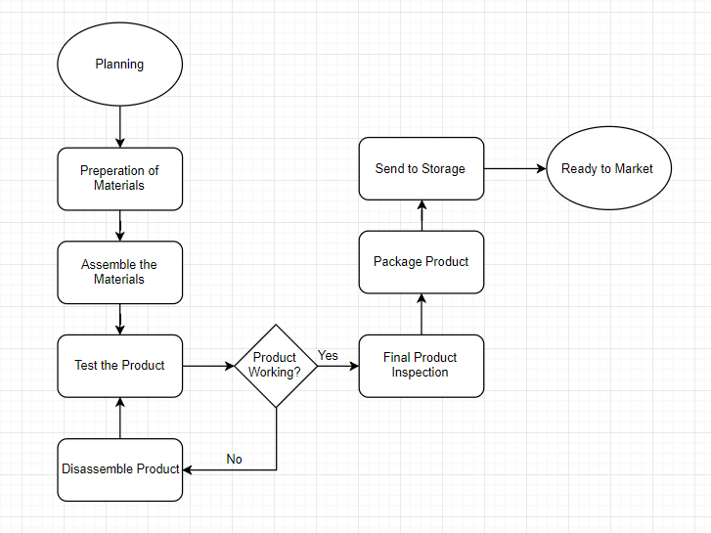

Figure. Process Flow Chart of CarWink

Assembly Parts

|  |  |  |
| --- | --- | --- |
| Assembly No. | Material | No. of Units |
| 1 | 3.5 Inches TFT LCD Screen Module 3.3V/5V | 1 |
| 2 | 3.5 Inches LCD Screen Module for Arduino Mega | 1 |
| 3 | Arduino Mega 2560 R3 | 1 |
| 4 | 3.7V Li-Ion Rechargeable Battery 200MAH | 1 |
| 5 | DFROBOT SOLAR PANEL (9V 220MA) | 1 |
| 6 | LM7805 Voltage Regulator | 1 |
| 7 | HC-05 Bluetooth Module Master-Slave | 1 |
| 8 | DC-DC XL6009 Buck 4A Adjustable Step Up Boost Booster Power Conversion Module | 1 |
| 9 | TP4056 1A Lipo Battery Charging Board Charger Module | 1 |
| 10 | SPDT Switch | 1 |
| 11 | Green LED | 1 |
| 12 | Car Window Suction Cup Mount Bracket Holder | 1 |
| 13 | Adhesives | 1 |
| 14 | Case | 1 |

Assembly Chart

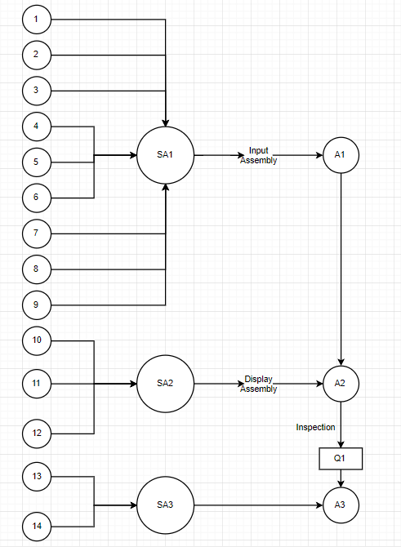

Figure. Assembly Chart of CarWink